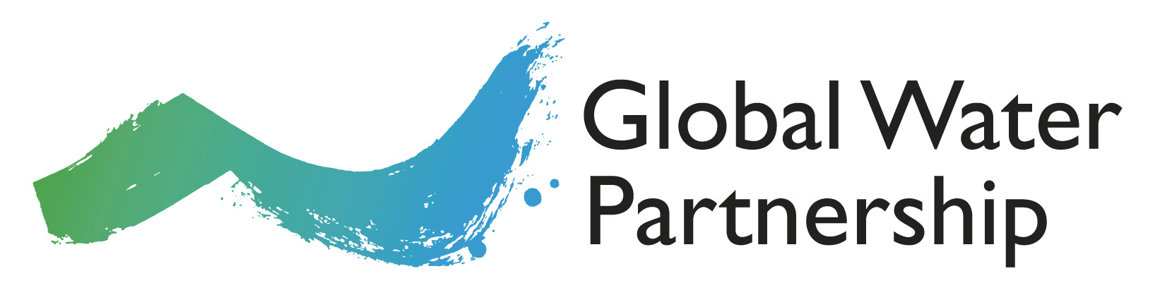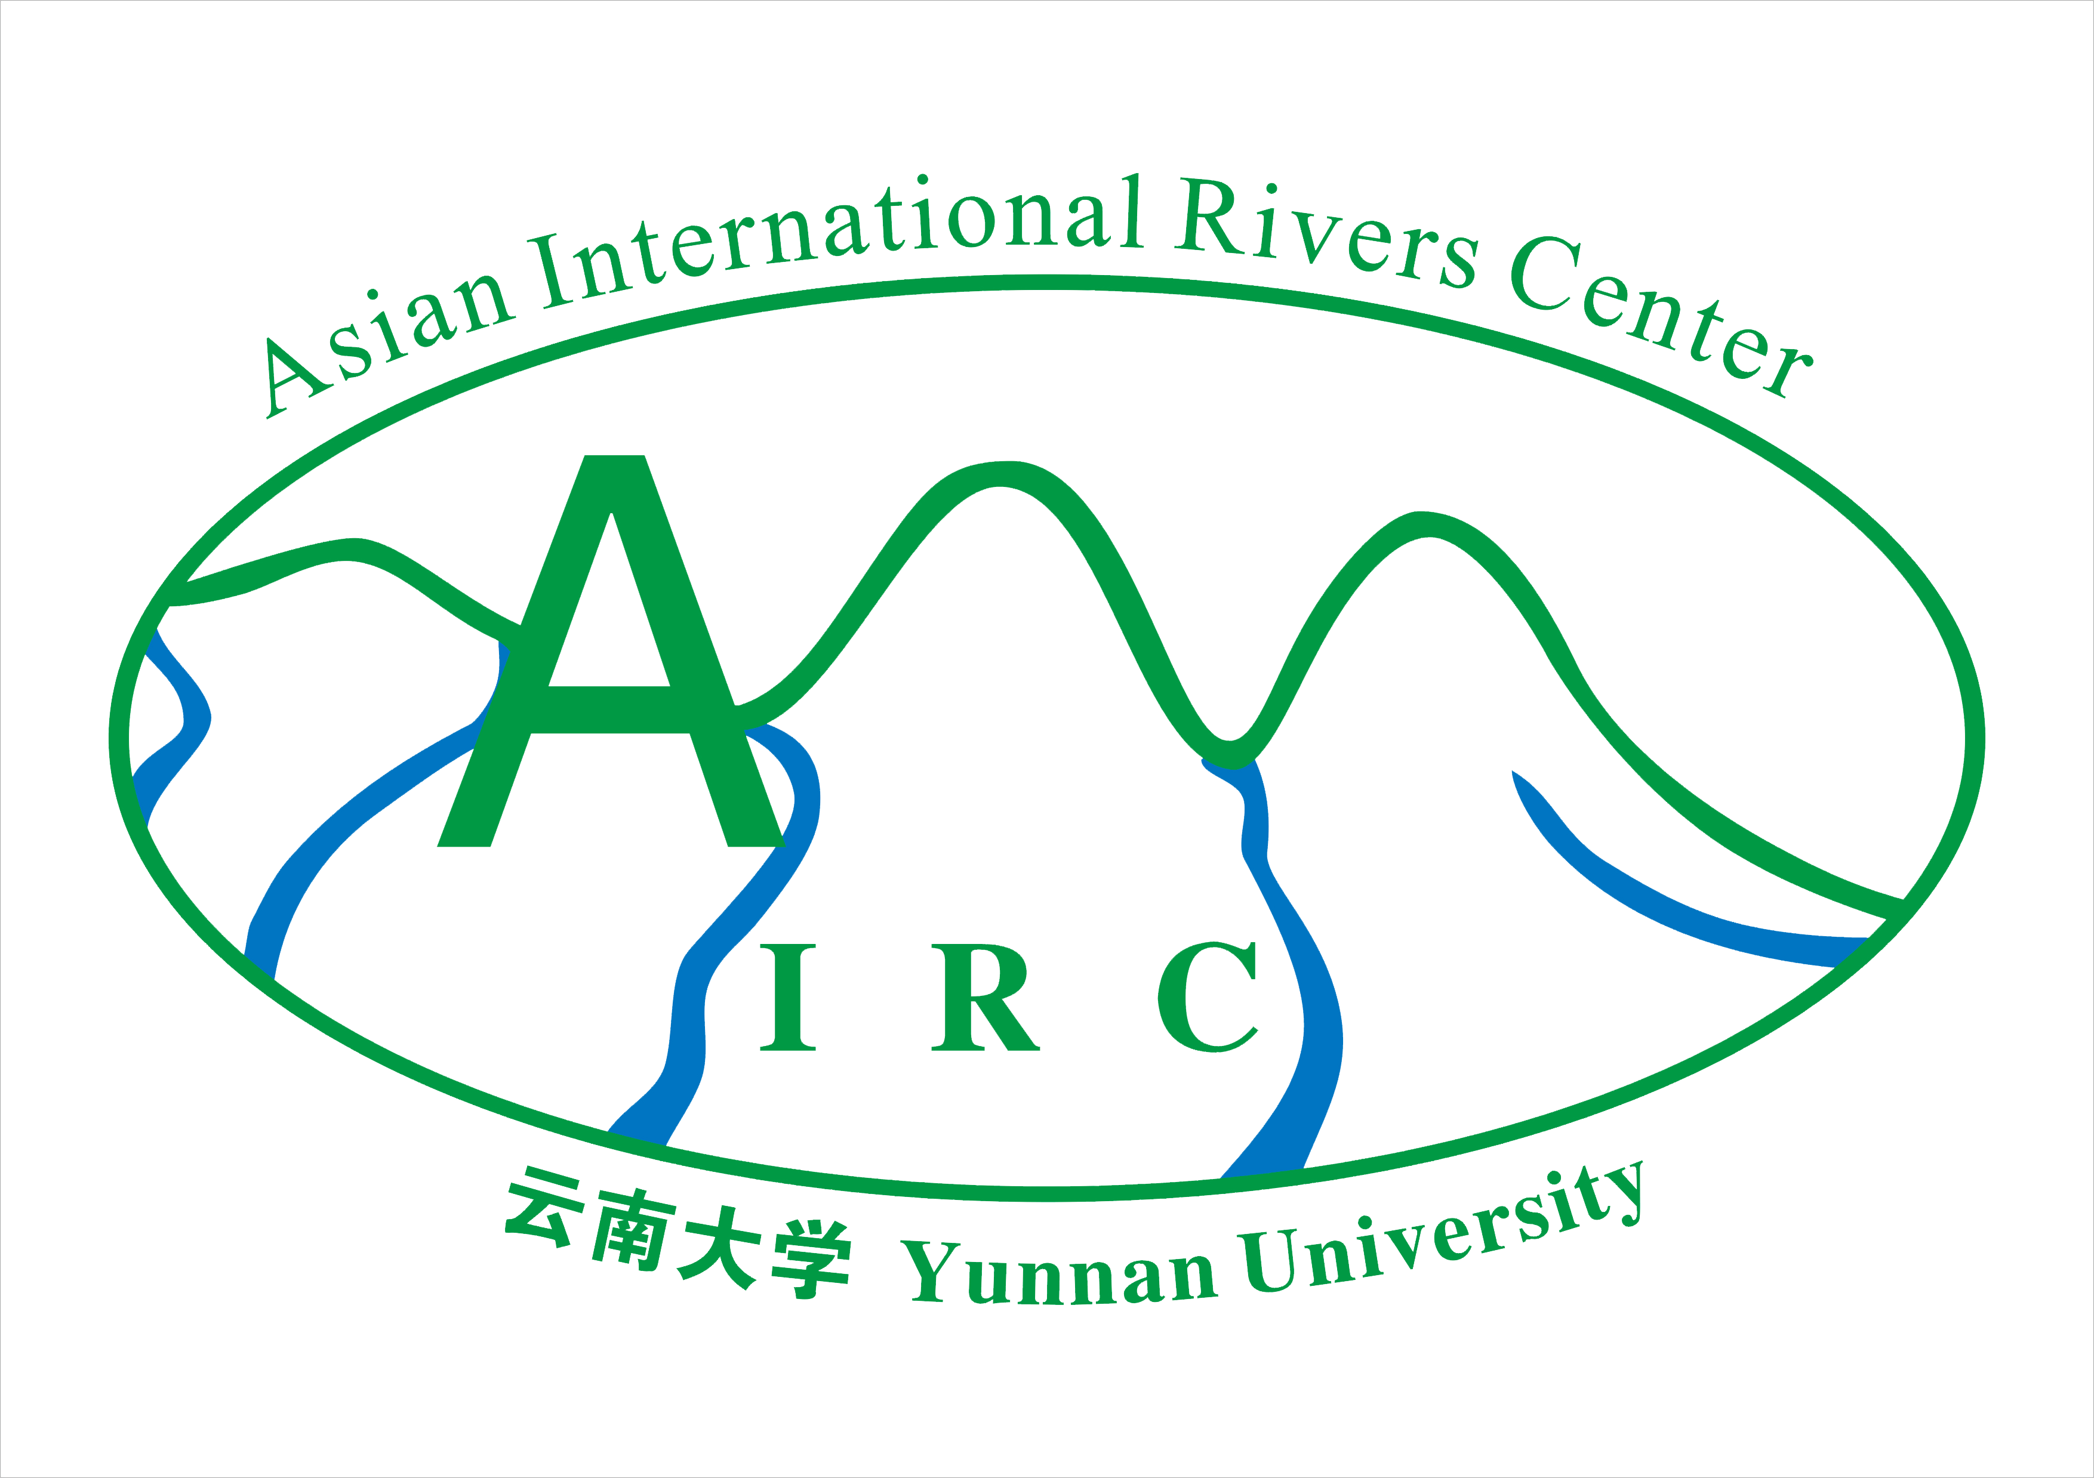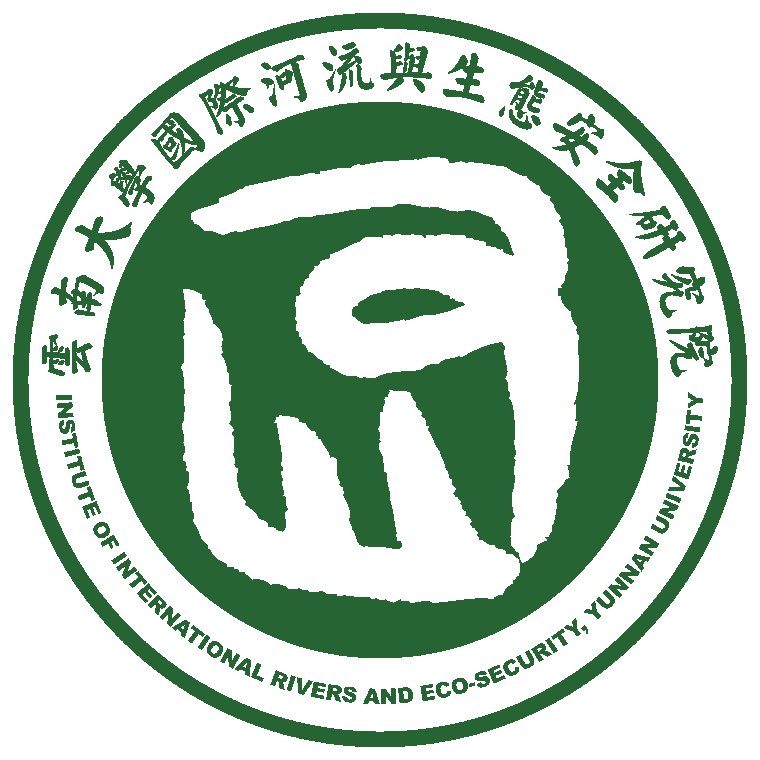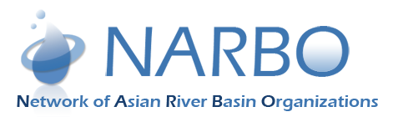

Pan-Asia Capacity Development Training Workshop on Water Governance:
International Water Law and Multi-Stakeholder Processes
13-15 December 2018, Yunnan University, Kunming, China

Application form

- Personal Details
Surname/family name:
First name(s)/Given name(s):
Title (Mr/Mrs/Miss/Ms/Dr):
Gender:
Date of Birth:
Nationality:
Passport number:
Country of issue:
Passport valid until:
Telephone number:
(incl. country and area code)
Email:
Dietary Restrictions:

- Experience
Mention only 4 latest jobs
Employer | From (mm/yy) | To (mm/yy) | Position

- Education
Mention only degree education
College/University attended | From (mm/yy) | To (mm/yy) | Title of degree awarded

- Partnerships and Affiliations (please indicate if you are a member of the GWP Partnership, NARBO, or another relevant group)
- Global Water Partnership (GWP)
- Network of Asia River Basin Organizations (NARBO)
- Other: _____________________________

To consider your application, it is much appreciated if you would kindly answer the following questions:
- Briefly describe the institution you currently work for (type of organization, mission, vision, objectives)
------------------------------------------------------------------------------------------------------------------------------------------------------------------------------------------------------------------------------------------------------------------------------------------------------------------------------------------------------------------------------------------------------------------------------------------------------------------------------------------------------------------------------------------------------------------------------------------------------------------------------------------------------
- Do you have any responsibilities related to management of transboundary water resources, basins/aquifers in your country and/or neighbouring countries? Give a brief description.
------------------------------------------------------------------------------------------------------------------------------------------------------------------------------------------------------------------------------------------------------------------------------------------------------------------------------------------------------------------------------------------------------------------------------------------------------------------------------------------------------------------------------------------------------------------------------------------------------------------------------------------------------
- How is this training relevant to your present work, and why would you like to participate?
------------------------------------------------------------------------------------------------------------------------------------------------------------------------------------------------------------------------------------------------------------------------------------------------------------------------------------------------------------------------------------------------------------------------------------------------------------------------------------------------------------------------------------------------------------------------------------------------------------------------------------------------------
- Have you attended any similar training programme(s) in water governance or water law before?
Y/N:
If yes, please specify
Where……………………………………………………………………………………………………………………………
When…………………………………………………………………………………………………………………………….
Theme of the training……………………………………………………………………………………………………
- Write a summary (max 150 words) of the case study you intend to share during the training (see guidance note in annex).
……………………………………………………………………………………………………………………………………………………………………………………………………………………………………………………………………………………………………………………………………………………………………………………………………………………………………………………………………………………………………………………………………………………………………………………………………………………………………………………………………………………………………………………………………………………………………………………………………………………………………………..
- In your position, how would you influence decision making within your institution/ministry/agency and/or contribute to better management of water on issues related to transboundary water resources?
------------------------------------------------------------------------------------------------------------------------------------------------------------------------------------------------------------------------------------------------------------------------------------------------------------------------------------------------------------------------------------------------------------------------------------------------------------------------------------------------------------------------------------------------------------------------------------------------------------------------------------------------------
- How does your workplace support your participation for the training in IWL?
------------------------------------------------------------------------------------------------------------------------------------------------------------------------------------------------------------------------------------------------------------------------------------------------------------------------------------------------------------------------------------------------------------------------------------------------------------------------------------------------------------------------
- Please indicate which institution is recommending you for the training.

------------------------------------------------------------------------------------------------------------------------------

Please check the type of participation you request:
While we would like for everyone to be able to attend and participate, limited funding is available for applicants with financial need. Therefore, we ask participants to either self-sponsor or seek an external sponsor for possible support (i.e. other development partners, etc.). Please indicate your financial ability/need below.
- Fully self-sponsored.
- Partial sponsorship: Accommodation, food and local transport during the workshop period
- Full sponsorship: Flight tickets, accommodation, food and local transport during the workshop period

I hereby certify that the information contained herein is truthful and authorize the selection committee to verify its accuracy.

Signature: _________________________

Place and date: _______________________

Annex 1: Applications Instructions
Please submit the following documents to apply for the training:
- Application form (available to download from GWP’s homepage www.gwp.org)
- A full CV and the contact information of two references
- A letter of motivation (description of past and current work as well as your suitability for the program)
- One letter of recommendation from your supervisor or place of work
- Copy of Passport
- Passport photo (digital copy, to size)

Please email the documents in Word or PDF to Mrs. Kathia Havens at kathia.havens@gwp.org, from whom further information on the training programme can be obtained. Applications will be accepted from October 8 to 26, 2018. Incomplete applications will not be considered for evaluation. Successful candidates will be notified by early November 2018. Participants who successfully complete the training will receive a Certificate of Attendance ratified by the course organisers.

Annex 2: Guidance note for the development of Case Studies
The case studies provide an opportunity for peer-to-peer learning amongst the participants. Each case study should illustrate an example of how international water governance, law, or multi-stakeholder processes, relating to transboundary waters (rivers, lakes and aquifers), has been, or might be, applied within a given context. These case studies may showcase how multi-stakeholder processes operate in the context of transboundary waters; a successful example of how international law has been put into practice; or they may show some of the challenges in applying the rules and principles of international law within a particular context.
The case studies might deal with one or more of the following:
- Experiences in transboundary water conflict and cooperation in Asia
- Evolution of international water law in Asia
- Experience working with multi-stakeholder processes/approaches and how they operate within the context of transboundary waters
- Regional approaches to transboundary water resources in Asia
- Substantive norms, e.g. how have/might key principles such as equitable and reasonable utilization, no significant harm, protection of ecosystems and prevention of pollution be applied in practice?
- Procedural rules, e.g. how have/might rules relating to notification and consultation on planned measures, data and information exchange, joint monitoring, stakeholder engagement be applied in practice?
- Institutional arrangements, e.g. what is/might be the role of river basin organizations, how efficient and effective have such institutions been in a particular context, what role and functions have they performed?
- Dispute settlement mechanisms, e.g. how have past disputes been resolved, or how might potential disputes be resolved? Have different dispute settlement mechanisms been used and to what effect, e.g. negotiation, conciliation, mediation, 3rd party fact-finding/expert panels, arbitration and adjudication?
- Implementing international water law through domestic legislation, e.g. to what extent have national laws been harmonized with transboundary commitments? Are there inconsistencies between international water law and national legal and institutional arrangements/ capacity?

The case study proposal will be 150 words max. Successful applicants will have an opportunity to share their case study in the form of a short presentation, and to further develop case studies after the workshop for potential inclusion in the GWP Toolbox.

